

Pitch Booking

Software Requirement Specification

Project Code: BP001

Document Code: D0001321– v<1.0>

**<Location, issued date of the Document>**

Record of change

*A - Added M - Modified D - Deleted

|  |  |  |  |  |
| --- | --- | --- | --- | --- |
| Effective Date | Changed Items | A* M, D | Change Description | New Version |
| 02/12/2016 | Initial | a | Add project over view |  |
|  |  |  |  |  |
|  |  |  |  |  |
|  |  |  |  |  |
|  |  |  |  |  |
|  |  |  |  |  |
|  |  |  |  |  |
|  |  |  |  |  |
|  |  |  |  |  |
|  |  |  |  |  |
|  |  |  |  |  |
|  |  |  |  |  |
|  |  |  |  |  |
|  |  |  |  |  |
|  |  |  |  |  |
|  |  |  |  |  |
|  |  |  |  |  |
|  |  |  |  |  |
|  |  |  |  |  |
|  |  |  |  |  |
|  |  |  |  |  |

SIGNATURE PAGE

**ORIGINATOR:** <Name> <Date>

<Position>

**REVIEWERS:** <Name> <Date>

<Position>

<Name, if it’s needed> <Date>

<Position>

**APPROVAL:** <Name> <Date>

<Position>

TABLE OF CONTENTS

1 Introduction 1

1.1 Purpose 1

1.2 Scope 1

1.3 Definitions, Acronyms, and Abbreviations 1

1.4 References 1

1.5 Overview 1

2 Overall Description 1

3 FUNCTIONAL Requirements 1

3.1 <Use Cases Diagram> 1

3.2 < Use Case 1: Log out> 1

3.3 < Use Case 2: Search pitch> 1

3.4 <Use case 3: View pitch on detail> 1

3.5 < Use Case 4: View all pitches> 1

3.6 < Use Case 5: Login> 1

3.7 < Use Case 6: Register> 1

3.8 < Use Case 7: Booking pitch> 1

3.9 < Use Case 8: Create football club> 1

3.10 < Use Case 9: Update your profile> 1

3.11 < Use Case 10: Create an external match> 1

3.12 < Use Case 11: Create an internal match> 1

3.13 < Use Case 12: View booked pitches history> 1

3.14 < Use Case 13: Rate, comment other clubs> 1

3.15 < Use Case 14: Search club> 1

3.16 < Use Case 15: View club on detail> 1

3.17 < Use Case 16: Join a club> 1

3.18 < Use Case 17: Consider request participation club > 1

3.19 < Use Case 18: Take attendance> 1

3.20 < Use Case 19: Create a pitch > 1

3.21 < Use Case 20: Update pitch> 1

3.22 < Use Case 21: Delete a pitch> 1

3.23 < Use Case 22: View my pitches> 1

3.24 < Use Case 23: View booked pitch history> 1

3.25 < Use Case 24: View upcoming matches> 1

3.26 < Use Case 25: Approve registration of host> 1

3.27 < Use Case 26: Ban an account> 1

3.28 < Use Case 27: Approve creation of a pitch> 1

3.29 < Use Case 28: View Reports> 1

3.30 < Use Case 29: Approve update of a pitch> 1

4 NON-FUNCTIONAL Requirements 1

4.1 Usability 1

4.2 Reliability 1

4.3 Performance 1

# Introduction

## Purpose

The purpose of this document is to build an online system to manage pitch booking and customer to ease the pitch booking management.

## Scope

The purpose of the online booking pitch is to ease booking pitch management and to create a convenient and easy-to-use application for customer, trying to book a pitch or find a competitor. The system is based on a relational database with its pitch management and reservation functions. We will have a server supporting of major cities around Viet Nam as well as thousands of pitches. Above all, we hope to provide a comfortable user experience along with the best pricing available

## Definitions, Acronyms, and Abbreviations

## References

## Overview

# Overall Description

* **Product perspective**
* Pitch detail:

It includes the pitch id, name, image, detail pitch, phone number etc.

* Customer description:

It includes the customer code, name, phone, avatar. This information may be used for keeping the records of the customer for any emergency or for any other kind of information

* Reservation description:

It includes the customer details, pitch number, date of booking,

* **User characteristics:**

The system will support three types of user privileges, Customers, Host and Administrator. Each user will have access to their own functions. The customer should be able to do the following function;

* Booking pitch
* Create Football Club
* Find an opponent team
* Find a team in your club for football match
* Report error
* Search pitch
* View history of booked pitches
* View the detail pitch
* Take attendance
* Join a club
* Search club
* View detail club
* Consider request participation club (Only the captain of the club can view it)

The Host should have following management functionalities:

* Create a pitch
* Update a pitch

- Delete a pitch

- Search pitch

* View upcoming match
* View booked pitch history
* View the detail pitch
* View my pitches

The Administrator should have following management functionalities:

* Approve register of host
* Ban a host
* Approve creation of pitch
* View list reports
* Approve update of pitch
* Approve delete of pitch
* Ban Customer
* Search Pitch
* View the detail pitch
* Approve a comment
* **Assumption Dependencies:**
* Calculation of high pitches (most frequent fliers) and calculating appropriate reward points for these pitches.
* Locate you then take out nearby pitch

# FUNCTIONAL Requirements

## <Use Cases Diagram>

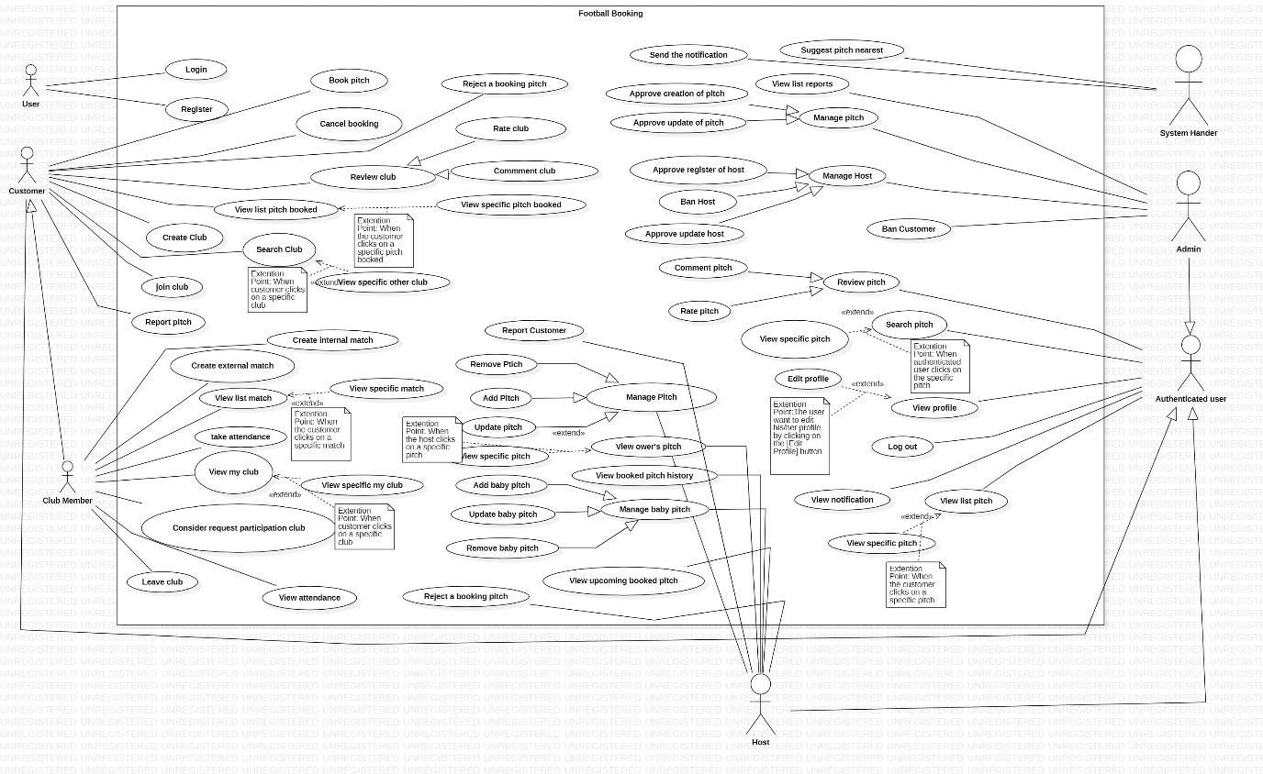

## <Log out>

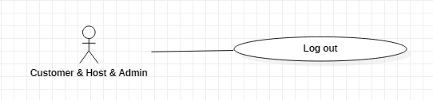

|  |  |  |  |  |
| --- | --- | --- | --- | --- |
| **USE CASE-1 SPECIFICATION z** | | | | |
| **Use-case No.** | UC001 | **Use-case Version** | | 1.0.1 |
| **Use-case Name** | Log out | | | |
| **Author** | Trần Dương Phúc An  Nguyễn Văn Hiếu  Nguyễn Đình Long  Nguyễn Vũ Long | | | |
| **Date** | 19/01/2021 | **Priority** | Normal | |
| **Actor:**  *Customer, Host, Admin*  **Summary:**  *As an above Customer or Host or Admin, I want to log out so that I can do something regarding to my role*  **Goal:**  *Customer or Host or Admin logs out an available account*  **Triggers**  *Customer or Host or Admin wants to log out*    **Preconditions:**  *Customer or Host or Admin successfully logged in this app*  *The Customer or Host or Admin 's device was connected to the internet when logging in*  **Post Conditions:**  *The user has successfully log out*  **Main Success Scenario:**     |  |  | | --- | --- | | **User** | **System** | | *On the main screen, User click the icon profile* | *System will show user’s profile and log out button at the bottom* | | *The user click log out button* | *System will show the confirm message”Do you want to log out”* | | *The user click ‘OK’ button* | *System will return the login screen* |   **Alternative Scenario:**  *Customer closes the app without logging out*  *Session time out*  **Exceptions:**  *NA*  **Relationships:**  *Login*  **Business Rules:**  *During 10 mins, if users don't do anything on this app, the application automatedly log out* | | | | |

## <Search pitch>

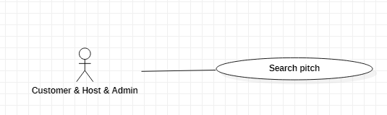

|  |  |  |  |  |
| --- | --- | --- | --- | --- |
| **USE CASE-2 SPECIFICATION z** | | | | |
| **Use-case No.** | UC002 | **Use-case Version** | | 1.0.1 |
| **Use-case Name** | Search pitches | | | |
| **Author** | Trần Dương Phúc An  Nguyễn Vũ Long  Nguyễn Đình Long  Nguyễn Văn Hiếu | | | |
| **Date** | 01/03/2021 | **Priority** | High | |
| **Actor:**  **Customer, Host, Admin**  **Summary:**  *As an above actor, I want to search pitches*  **Goal:**  *Finding pitches*  **Triggers**  Clicking on search symbol to search pitches  **Preconditions:**  - User’s device needs to be connected in the internet  - User successfully logged in this app with customer account  **Post Conditions:**  *NA*  **Main Success Scenario:**     |  |  | | --- | --- | | **Authenticated user** | **System** | | User type name’s pitch on the search bar of main screen | The system will recommend the pitch during searching | | User click the search symbol to search club | The list of pitches will be showed based on search value  - Each pitch will display some basic information such as:  • Name:  • Avatar:  • Phone:  • Address: |   **Alternative Scenario:**  *NA*  **Exceptions:**  *System will pop up an announcement if searched pitches are not found*  **Relationships:**  Login  **Business Rules:**  *NA* | | | | |

## <View pitch on detail>

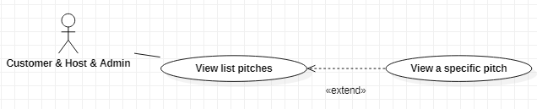

|  |  |  |  |  |
| --- | --- | --- | --- | --- |
| **USE CASE-3 SPECIFICATION z** | | | | |
| **Use-case No.** | UC003 | **Use-case Version** | | 1.0.1 |
| **Use-case Name** | View a pitch on detail | | | |
| **Author** | Trần Dương Phúc An  Nguyễn Vũ Long  Nguyễn Đình Long  Nguyễn Văn Hiếu | | | |
| **Date** | 2/03/2021 | **Priority** | High | |
| **Actor:**  *Customer, Host, Admin*  **Summary:**  *As an above actor, I want to view a pitch on detail so that I can get some information about the pitch*  **Goal:**  *Viewing a pitch on detail*  **Triggers**  *Clicking on a specific pitch in list of pitches to view it on detail*  *The screen will show:*  **Preconditions:**  *User’s device needs to be connected in the internet*  *User successfully logged in this app*  **Post Conditions:**  *Some detailed information of a pitch will be displayed*  **Main Success Scenario:**     |  |  | | --- | --- | | **Authenticated user** | **System** | | User log in successfully | *System redirects user to the main screen where list of all pitches will be displayed on the screen*  *Each pitch will be displayed some basic information:*  *• Name:*  *• Avatar:*  *• Phone:*  *• Address:* | | User choose a specific pitch and clicks on it | *The specific pitch’s information will be displayed on the screen:*  *• Name:*  *• Address:*  *• Time Start:*  *• Time End:*  *• Phone:*  *• Image:*  *• Quantity of baby pitches:*  *• Price depending on Time:* |   **Alternative Scenario:**  *NA*  **Exceptions:**  *NA*  **Relationships:**  Login  *View all pitches*  **Business Rules:**  *NA* | | | | |

## <View all pitches>

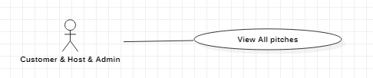

|  |  |  |  |  |
| --- | --- | --- | --- | --- |
| **USE CASE-4 SPECIFICATION z** | | | | |
| **Use-case No.** | UC004 | **Use-case Version** | | 1.0.1 |
| **Use-case Name** | View All Pitches | | | |
| **Author** | Trần Dương Phúc An  Nguyễn Vũ Long  Nguyễn Đình Long  Nguyễn Văn Hiếu | | | |
| **Date** | 2/03/2021 | **Priority** | High | |
| **Actor:**  *Customer, Host, Admin*  **Summary:**  *As an above actor, I want to view list of all pitches*  **Goal:**  *Viewing all pitches*  **Triggers**  *I* want to view all pitches  **Preconditions:**  *User’s device needs to be connected in the internet*  *User successfully logged in this app with host account*  **Post Conditions:**  *All pitches will be displayed on the screen*  **Main Success Scenario:**   |  |  | | --- | --- | | **Authenticated user** | **System** | | User log in successfully | *System redirects user to the main screen where list of all pitches will be displayed on the screen*  *Each pitch will be displayed some basic information:*  *• Name:*  *• Avatar:*  *• Phone:*  *• Address:* |   **Alternative Scenario:**  *NA*  **Exceptions:**  *NA*  **Relationships:**  Login  Search pitches  *View a pitch on detail*  **Business Rules:**  *NA* | | | | |

## <Login>

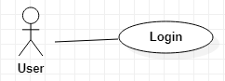

|  |  |  |  |  |
| --- | --- | --- | --- | --- |
| **USE CASE-5 SPECIFICATION z** | | | | |
| **Use-case No.** | UC005 | **Use-case Version** | | 1.0.1 |
| **Use-case Name** | Login | | | |
| **Author** | Trần Dương Phúc An  Nguyễn Văn Hiếu  Nguyễn Đình Long  Nguyễn Vũ Long | | | |
| **Date** | 19/01/2021 | **Priority** | High | |
| **Actor:**  *Guest, Google, Facebook, Twitter*  **Summary:**  *As a guest, I want to login so that I can be verified as a valid member*  **Goal:**  *Required to be authorized for using this app*  **Triggers**  *This use case works when this app has just been activated*  **Preconditions:**  *Account was registered successfully*  *The user's device was connected to the internet when logging in*  **Post Conditions:**  *The user has successfully logged in to the application*  *The system records successful login activity to Activity Log.*  **Main Success Scenario:**     |  |  | | --- | --- | | **User** | **System** | | User click the application | System will redirect to the login screen.  There will be displayed two textbox:   * Username * Password | | User enters account and password then selecting login command | The system validates login information successfully and allows the user to access the application.  The system records successful login activity to Activity Log. |   **Alternative Scenario:**  *Users choose the method to log in by their Facebook, Gmail, Twitter account*  *The system switches to the login screen of Facebook, Gmail, Twitter*  *The user enters the Facebook, Gmail, Twitter account and selects the login command*  *Facebook, Gmail, Twitter successfully validates the login information and allows the user to access the application*  *The system records successful login activity to Activity Log.*  **Exceptions:**  *The system has checked validation of account incorrectly then the message will be displayed. “User is wrong” if system doesn’t find any username or “password is wrong” if password is not correct*  **Relationships:**  *Register*  **Business Rules:**  *Users who enter incorrect account or password for the 6th consecutive time will be locked out of their account for 30 minutes.* | | | | |

## <Register>

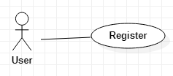

|  |  |  |  |  |
| --- | --- | --- | --- | --- |
| **USE CASE-6 SPECIFICATION z** | | | | |
| **Use-case No.** | UC006 | **Use-case Version** | | 1.0.1 |
| **Use-case Name** | Register | | | |
| **Author** | Trần Dương Phúc An  Nguyễn Văn Hiếu  Nguyễn Đình Long  Nguyễn Vũ Long | | | |
| **Date** | 19/01/2021 | **Priority** | High | |
| **Actor:**  *Guest*  **Summary:**  *As a guest, I want to register an account so that I can do something regarding to my role*  **Goal:**  *Registering a new account*  **Triggers**  *This use case works when guest doesn’t have an available account*  **Preconditions:**  *User inputs all necessary information that this app required*  *The user's device was connected to the internet when logging in*  **Post Conditions:**  *The user has successfully registered into the application*  *The application automatically logs in with the newly created account*  **Main Success Scenario:**     |  |  | | --- | --- | | **User** | **System** | | User click registration button on the login screen | System will redirect user to the register account. The screen will be showed:  •User Name:  •Password:  •Confirm Password:  •Full Name:  •Phone Number: | | User fill all field, user need to click the register button | - Application redirect to the confirming screen which has one textbox and 1 button  - System will send an OTP code to this phone number. | | User needs to get this code and enter it to the textbox for confirming in the application | The system verifies successful registration information and allows users to access the application |   **Alternative Scenario:**  *Registration is required*  **Exceptions:**  *The system has checked validation of field incorrectly then displays a message*  *User name is existed then displays a message*  **Relationships:**  *NA*  **Business Rules:**  *NA* | | | | |

## <View list match>

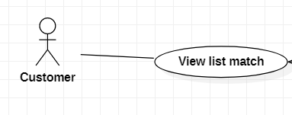

|  |  |  |  |  |
| --- | --- | --- | --- | --- |
| **USE CASE-7 SPECIFICATION z** | | | | |
| **Use-case No.** | UC007 | **Use-case Version** | | 1.0.1 |
| **Use-case Name** | View list match | | | |
| **Author** | Trần Dương Phúc An  Nguyễn Văn Hiếu  Nguyễn Đình Long  Nguyễn Vũ Long | | | |
| **Date** | 19/01/2021 | **Priority** | Hard | |
| **Actor:**  *Customer*  **Summary:**  *As a member in that club, I want to view all my matches, so I know which match I participate in*  **Goal:**  *Viewing list match*  **Triggers**  *Customer want to view all their match*  **Preconditions:**  *- User’s device needs to be connected in the internet*  *- User successfully logged in this app with customer account*  *- User is a member of club*  *- that club must have at least one match*  **Post Conditions:**  *The list of user's match will be showed*  **Main Success Scenario:**     |  |  | | --- | --- | | **Customer** | **System** | | Customer click on the 2 swords icon located on the bar | System will redirect to the match screen, the list upcoming match will be showed  - Each match will have:  * Name's club  * Time Start  * Time End  * Date  * The type of match(internal match or external match) |   **Alternative Scenario:**  *N/A*  **Exceptions:**    **Relationships:**  *- Login*  *- View profile*  **Business Rules:**  *NA* | | | | |

## <View specific match>

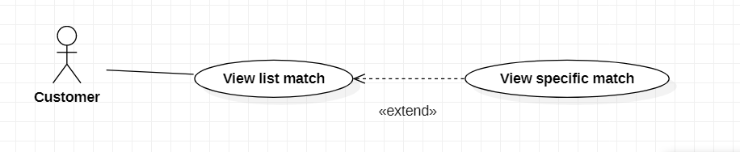

|  |  |  |  |  |
| --- | --- | --- | --- | --- |
| **USE CASE-7 SPECIFICATION z** | | | | |
| **Use-case No.** | UC007 | **Use-case Version** | | 1.0.1 |
| **Use-case Name** | View specific match | | | |
| **Author** | Trần Dương Phúc An  Nguyễn Văn Hiếu  Nguyễn Đình Long  Nguyễn Vũ Long | | | |
| **Date** | 19/01/2021 | **Priority** | Hard | |
| **Actor:**  *Customer*  **Summary:**  *As a member in that club, I want to view specific match, so I know more about this match*  **Goal:**  *View specific match*  **Triggers**  *Customer want to view specific match*  **Preconditions:**  *- User’s device needs to be connected in the internet*  *- User successfully logged in this app with customer account*  *- User is a member of club*  *- That club must have at least one match*  **Post Conditions:**  *The user has successfully ordered pitch*  **Main Success Scenario:**     |  |  | | --- | --- | | **Customer** | **System** | | Customer click on the 2 swords icon located on the bar | System will redirect to the match screen, the list upcoming match will be showed | | User need to choose a specific pitch | System redirects to detail match screen, the information of this match will be showed specificly:  * Name's club  * Name's pitch  * Time Start  * Time End  * Date  * The type of match(internal match or external match)  * If there is the external match, there will have the logo and  name of opponent team  * the button view attendance | | User fill all this information | the total price will show | | On the below, the customer clicks the button booking to book a pitch | - The system shows the successful book pitch message  - User will be redirected to the main screen |   **Alternative Scenario:**  *N/A*  **Exceptions:**  *The pitch time up*  *The pitch closed unexpectedly*  *There is not available pitch*  **Relationships:**  *Login*  View a pitch on detail  **Business Rules:**  *NA* | | | | |

## <View my club>

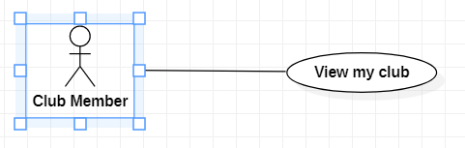

|  |  |  |  |  |
| --- | --- | --- | --- | --- |
| **USE CASE-7 SPECIFICATION z** | | | | |
| **Use-case No.** | UC007 | **Use-case Version** | | 1.0.1 |
| **Use-case Name** | View my clubs | | | |
| **Author** | Trần Dương Phúc An  Nguyễn Văn Hiếu  Nguyễn Đình Long  Nguyễn Vũ Long | | | |
| **Date** | 19/01/2021 | **Priority** | Hard | |
| **Actor:**  *Customer*  **Summary:**  *As a member in that club, I want to view all my clubs, so I know which clubs I'm a member of*  **Goal:**  *Viewing member's club*  **Triggers**  *Customer want to view all their club*  **Preconditions:**  *- User’s device needs to be connected in the internet*  *- User successfully logged in this app with customer account*  *- User is a member of that club*  **Post Conditions:**  *the list of user's clubs will be showed*  **Main Success Scenario:**     |  |  | | --- | --- | | **Customer** | **System** | | User need to click the profile icon on the top-right corner of main screen | -System redirect to profile screen  -In the profile screen, there are my club section. In my club section, user will view all their clubs.  Each club will have:  * Club's logo  * Name | |  |  |   **Alternative Scenario:**  *N/A*  **Exceptions:**  NA  **Relationships:**  *- Login*  *- View Profile*  **Business Rules:**  *NA* | | | | |

## <Leave club>

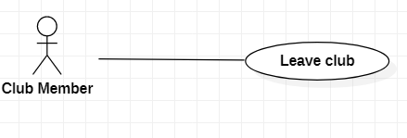

|  |  |  |  |  |
| --- | --- | --- | --- | --- |
| **USE CASE-7 SPECIFICATION z** | | | | |
| **Use-case No.** | UC007 | **Use-case Version** | | 1.0.1 |
| **Use-case Name** | Leave club | | | |
| **Author** | Trần Dương Phúc An  Nguyễn Văn Hiếu  Nguyễn Đình Long  Nguyễn Vũ Long | | | |
| **Date** | 19/01/2021 | **Priority** | Hard | |
| **Actor:**  *Customer*  **Summary:**  *As a member in that club, I want to leave a club, so I don't want to be a member of that club*  **Goal:**  *Customer won't be a member of that club anymore*  **Triggers**  *Customer want to leave a club*  **Preconditions:**  *- User’s device needs to be connected in the internet*  *- User successfully logged in this app with customer account*  *- User is a member of that club*  **Post Conditions:**  *Customer is not a member of that club anymore*  **Main Success Scenario:**     |  |  | | --- | --- | | **Customer** | **System** | | User need to click the profile icon on the top-right corner of main screen | - System will redirect to the profile screen.  -In the profile screen, it has my club section.  - In my club section, there is a list of user’s clubs | | user choose specific club | -System will redirect to detail club screen. In the detail club screen, there is a leave club button at the bottom | | user click that button | the notification will show "Do you want to leave that club" | | user click 'ok' | The user will be redirected to the profile and that club will be disabled in the My Clubs section |   **Alternative Scenario:**  *N/A*  **Exceptions:**  *The pitch time up*  *The pitch closed unexpectedly*  *There is not available pitch*  **Relationships:**  *-Login*  *- View Profile*  *- View the specific club*  **Business Rules:**  *NA* | | | | |

## <Cancel Booking>

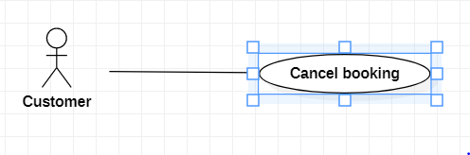

|  |  |  |  |  |
| --- | --- | --- | --- | --- |
| **USE CASE-7 SPECIFICATION z** | | | | |
| **Use-case No.** | UC007 | **Use-case Version** | | 1.0.1 |
| **Use-case Name** | Cancel booking | | | |
| **Author** | Trần Dương Phúc An  Nguyễn Văn Hiếu  Nguyễn Đình Long  Nguyễn Vũ Long | | | |
| **Date** | 19/01/2021 | **Priority** | Hard | |
| **Actor:**  *Customer*  **Summary:**  *As a customer, I want to cancel a booking pitch, so that customer can be safe when they have an unexpected problem*  **Goal:**  *The booking pitch is discarded*  **Triggers**  *Customer want to discard the booked pitch*  **Preconditions:**  *- User’s device needs to be connected in the internet*  *- User successfully logged in this app with customer account*  *- User booked a pitch*  **Post Conditions:**  *- User's booking pitch is discarded*  **Main Success Scenario:**     |  |  | | --- | --- | | **Customer** | **System** | | Customer click on the view history button on main screen at the bottom | System will redirect to view history screen, there are a list of history booked pitch. On the side of each pitch there will be a cancel button | | user click that button | The notification will show "Do you want to discard it" | | user click 'ok' | pitch will be disappeared in the history |   **Alternative Scenario:**  *N/A*  **Exceptions:**  NA  **Relationships:**   * *Login* * *View list math* * *View specific match*   **Business Rules:**  *NA* | | | | |

## <View Attendance>

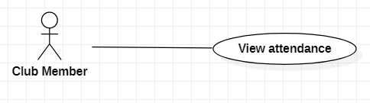

|  |  |  |  |  |
| --- | --- | --- | --- | --- |
| **USE CASE-7 SPECIFICATION z** | | | | |
| **Use-case No.** | UC007 | **Use-case Version** | | 1.0.1 |
| **Use-case Name** | View attendance | | | |
| **Author** | Trần Dương Phúc An  Nguyễn Văn Hiếu  Nguyễn Đình Long  Nguyễn Vũ Long | | | |
| **Date** | 19/01/2021 | **Priority** | Hard | |
| **Actor:**  *Customer*  **Summary:**  *As a member in that club, I want to view attendance of this club, so that I can know*  *all member's state*  **Goal:**  *Viewing attendance*  **Triggers**  *User want to view attendance of their team*  **Preconditions:**  *- User’s device needs to be connected in the internet*  *- User successfully logged in this app with customer account*  *- User is a member of club*  *- that club must have at least one match*  **Post Conditions:**  *- The information of attendance team members*  **Main Success Scenario:**     |  |  | | --- | --- | | **Customer** | **System** | | Customer click on the 2 swords icon located on the bar | System will redirect to the match screen, the list upcoming match will be showed | | Customer choose a specific pitch | System redirects to detail match screen and shows button attendance | | Customer click on that button | The screen attendance will be showed:  -There are 3 color which represent three state of attendance.  - Red means 'I don't join this match'  -Yellow means 'Maybe I join this match'  -Green means 'I will join this match'  -Members' avatars will appear next to the color corresponding to their attendance status |   **Alternative Scenario:**  *N/A*  **Exceptions:**    **Relationships:**  *- Login*  *- View list match*  *- View specific match*  **Business Rules:**  *NA* | | | | |

## <Booking pitch>

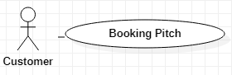

|  |  |  |  |  |
| --- | --- | --- | --- | --- |
| **USE CASE-7 SPECIFICATION z** | | | | |
| **Use-case No.** | UC007 | **Use-case Version** | | 1.0.1 |
| **Use-case Name** | Booking pitch | | | |
| **Author** | Trần Dương Phúc An  Nguyễn Văn Hiếu  Nguyễn Đình Long  Nguyễn Vũ Long | | | |
| **Date** | 19/01/2021 | **Priority** | Hard | |
| **Actor:**  *Customer*  **Summary:**  *As a customer, I want to book a pitch*  **Goal:**  *Booking pitch*  **Triggers**  *Customers want to book pitches*  **Preconditions:**  *User successfully logged in this app as a customer*  *The user's device was connected to the internet when logging in*  **Post Conditions:**  *The user has successfully ordered pitch*  **Main Success Scenario:**     |  |  | | --- | --- | | **Customer** | **System** | | The customer chooses the pitch by search or choose a pitch on the view all pitch on the main screen | System will redirect to the detail pitch screen, the button pitch booking displayed at bottom | | User click that button | the booking pitch screen will be displayed:  • Textbox of date  • Textbox of Time Start  • Textbox of Time End | | User fill all this information | the total price will show | | On the below, the customer clicks the button booking to book a pitch | - The system shows the successful book pitch message  - User will be redirected to the main screen |   **Alternative Scenario:**  *N/A*  **Exceptions:**  *The pitch time up*  *The pitch closed unexpectedly*  *There is not available pitch*  **Relationships:**  *Login*  View a pitch on detail  **Business Rules:**  *NA* | | | | |

## <Create football club>

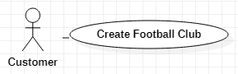

|  |  |  |  |  |
| --- | --- | --- | --- | --- |
| **USE CASE-8 SPECIFICATION z** | | | | |
| **Use-case No.** | UC008 | **Use-case Version** | | 1.0.1 |
| **Use-case Name** | Create Football Club | | | |
| **Author** | Trần Dương Phúc An  Nguyễn Vũ Long  Nguyễn Đình Long  Nguyễn Văn Hiếu | | | |
| **Date** | 19/01/2021 | **Priority** | Low | |
| **Actor:**  *Customer*  **Summary:**  *As a customer, I want to create a new football club so that people could join and plan for football matches*  **Goal:**  *Create a new club*  **Triggers**  *Customer wants to create a new football Club*  **Preconditions:**  *User’s device needs to be connected in the internet*  *User successfully logged in this app with customer account*  **Post Conditions:**  *A new club is created*  *The system will anounce for creating a new club successfully*  **Main Success Scenario:**   |  |  | | --- | --- | | **Customer** | **System** | | *User click icon profile on the bottom-right corner of the screen* | System will show user’s profile | | *In the profile screen, user click the create club button* | A club creation form will be displayed:  *• Name:(required)*  *• Logo Image:*  *• Description:*  *• Average age of member: (required)*  *• Home Pitch: (required)*  *• Skills:* | | *User enters required information of football club and clicks Create button at the bottom* | *The system will create a new club if the validation of information is correct* |   **Alternative Scenario:**  *NA*  **Exceptions:**  *The system will display a message if user doesn’t enter some important information*  **Relationships:**  *NA*  **Business Rules:**  *NA* | | | | |

## <Update your profile>

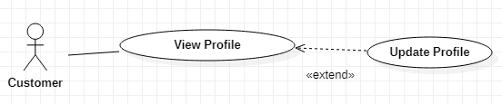

|  |  |  |  |  |
| --- | --- | --- | --- | --- |
| **USE CASE-9 SPECIFICATION z** | | | | |
| **Use-case No.** | UC009 | **Use-case Version** | | 1.0.1 |
| **Use-case Name** | Update your personal information (your profile) | | | |
| **Author** | Trần Dương Phúc An  Nguyễn Vũ Long  Nguyễn Đình Long  Nguyễn Văn Hiếu | | | |
| **Date** | 19/01/2021 | **Priority** | normal | |
| **Actor:**  *Customer*  **Summary:**  *As a user, I want to update my profile so that my personal information would be valid*  **Goal:**  *Update my profile*  **Triggers**  *Users want to update their profiles*  **Preconditions:**  *User’s device needs to be connected in the internet*  *User successfully logged in this app with customer account*  **Post Conditions:**  *User’s profile will be updated*  *The system will anounce for updating new information successfully*  **Main Success Scenario:**   |  |  | | --- | --- | | **Customer** | **System** | | *User click icon Profile on the bottom-right corner of the main screen* | System will show user’s profile | | *User clicks in Update Profile button* | A profile update form will be displayed:   * *Name* * *Age* * *Phone Number* * *Address* * *Avatar Image* | | *User enters information and clicks Update button at the bottom* | *The system will update user’s profile if the validation of information is correct* |   **Alternative Scenario:**  *NA*  **Exceptions:**  *The system will check the validation of updating profile and display announcements if user’s inputs are not valid*  **Relationships:**  NA  **Business Rules:**  *NA* | | | | |
|  | | | | |

## <Create an external match>

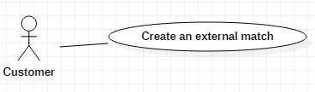

|  |  |  |  |  |
| --- | --- | --- | --- | --- |
| **USE CASE-10 SPECIFICATION z** | | | | |
| **Use-case No.** | UC0010 | **Use-case Version** | | 1.0.1 |
| **Use-case Name** | Create an external match (out of football club) | | | |
| **Author** | Trần Dương Phúc An  Nguyễn Vũ Long  Nguyễn Đình Long  Nguyễn Văn Hiếu | | | |
| **Date** | 19/01/2021 | **Priority** | Normal | |
| **Actor:**  *Customer*  **Summary:**  *As a user, I want to find opponent teams so that my team could have a football match with them*  **Goal:**  *Finding opponent teams for a football match*  **Triggers**  *Users want to find an opponent team for a football match*  **Preconditions:**  *User’s device needs to be connected in the internet*  *User successfully logged in this app with customer account*  *Customer has their own club*  **Post Conditions:**  *The system will put your schedule in the list of finding opponent team*  *The system will anounce your team that there is an opponent team which matches yours*  **Main Success Scenario:**   |  |  | | --- | --- | | **Customer** | **System** | | *User clicks on the create match button, the second icon is in the nav bar at the bottom* | System will show creation match form   * Team (drop list) (required) * Radio button (choose internal or external) (required) * Pitch (required) * Time (required) * Phone (required) * Minimum number of player(option) | | *User input required information, choose external button and then click Create button* | *The system will create external match if the validation of information is correct* |   **Alternative Scenario:**  *NA*  **Exceptions:**  *The system will display a message if user doesn’t enter required field*  **Relationships:**  *NA*  **Business Rules:**  *NA* | | | | |

## <Create an internal match>

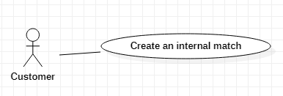

|  |  |  |  |  |
| --- | --- | --- | --- | --- |
| **USE CASE-11 SPECIFICATION z** | | | | |
| **Use-case No.** | UC011 | **Use-case Version** | | 1.0.1 |
| **Use-case Name** | Create an internal match (in football club) | | | |
| **Author** | Trần Dương Phúc An  Nguyễn Vũ Long  Nguyễn Đình Long  Nguyễn Văn Hiếu | | | |
| **Date** | 19/01/2021 | **Priority** | Normal | |
| **Actor:**  *Customer*  **Summary:**  *As a user, I want to find a team in a club so that I could have a football match with other teams in the club*  **Goal:**  *Finding a team in a football club for a football match*  **Triggers**  *Users want to find a team in a club for football match*  **Preconditions:**  *User’s device needs to be connected in the internet*  *User successfully logged in this app with customer account*  *Customer is required to be a member of a club*  **Post Conditions:**  *The system will put your match in the list of finding a team in your club*  *The system will anounce all people who join for the match if it is enough people*  *User would have a football match with a team in a club*  **Main Success Scenario:**   |  |  | | --- | --- | | **Customer** | **System** | | *User clicks on the create match button, the second icon is in the nav bar at the bottom* | System will show creation match form   * Team (drop list) (required) * Radio button (choose internal or external) (required) * Pitch (required) * Time (required) * Phone (required) * Minimum number of player(option) | | *User input required information, choose internal button and then click Create button* | *The system will create internal match if the validation of information is correct* |   **Alternative Scenario:**  *NA*  **Exceptions:**  *The system will display a message if user doesn’t enter the time or the name of soccer field*  **Relationships:**  NA  **Business Rules:**  *NA* | | | | |

## <View booked pitches history>

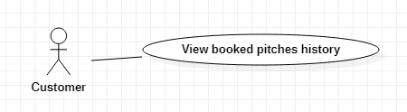

|  |  |  |  |  |
| --- | --- | --- | --- | --- |
| **USE CASE-12 SPECIFICATION z** | | | | |
| **Use-case No.** | UC012 | **Use-case Version** | | 1.0.1 |
| **Use-case Name** | View history of booked pitches | | | |
| **Author** | Trần Dương Phúc An  Nguyễn Vũ Long  Nguyễn Đình Long  Nguyễn Văn Hiếu | | | |
| **Date** | 01/03/2021 | **Priority** | Normal | |
| **Actor:**  **Customer**  **Summary:**  *As a customer, I want to view a history of booked pitch*  **Goal:**  *Viewing customer’s booked pitches*  **Triggers**  *Customer wants to view* history of booked pitches  **Preconditions:**  *User’s device needs to be connected in the internet*  *User successfully logged in this app with customer account*  **Post Conditions:**  *NA*  **Main Success Scenario:**   |  |  | | --- | --- | | **Customer** | **System** | | *User clicks Calendar icon on the main screen* | System will show customer’s list of booking pitch | | *User clicks Time icon on the booking pitch screen* | *The system will retrieve a list of pitches that the user has booked.* | | *User clicks one of that list* | *The system will show form:*   * *Pitch name:* * *Address:* * *Phone:* * *Start time:* * *End time:* * *Total:* |   **Alternative Scenario:**  *NA*  **Exceptions:**  *NA*  **Relationships:**  Login  **Business Rules:**  *NA* | | | | |

## <Rate, comment other clubs>

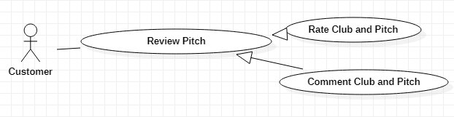

|  |  |  |  |  |
| --- | --- | --- | --- | --- |
| **USE CASE-13 SPECIFICATION z** | | | | |
| **Use-case No.** | UC013 | **Use-case Version** | | 1.0.1 |
| **Use-case Name** | Rate, comment other clubs | | | |
| **Author** | Trần Dương Phúc An  Nguyễn Vũ Long  Nguyễn Đình Long  Nguyễn Văn Hiếu | | | |
| **Date** | 01/03/2021 | **Priority** | Low | |
| **Actor:**  **Customer**  **Summary:**  *As a customer, I want to rate or comment other clubs so that everyone will know better about that club*  **Goal:**  *Customer rates and comments to other clubs*  **Triggers**  *Customer want to rate, comment*  **Preconditions:**  *User’s device needs to be connected in the internet*  *User successfully logged in this app with customer account*  **Post Conditions:**  *Create a rate or comment for 1 club*  **Main Success Scenario:**   |  |  | | --- | --- | | **Customer** | **System** | | *User click icon profile on the bottom-right corner of the screen* | System will show user’s profile | | *In the profile screen, user clicks on the magnifying glass icon to search club and input name of club* | System will show list of club | | *User chooses one to view detail club* | *System will show detail of club. There are textbox for comment and rating* | | *In the detail club, user could type the comment in textbox and choose stars for rating a club and clicks submit to create a comment and rate* | *System will insert that comment and rating into that club.*  *-Then it will show customer’s comment and rating at the below of detail club* |   **Alternative Scenario:**  *NA*  **Exceptions:**  *Customer do not type anything in the textbox comment before click submit button.*  *The notification will be showed with message “Please type something in here”*  **Relationships:**  Login  *Search club*  **Business Rules:**  *NA* | | | | |

## <Search club>

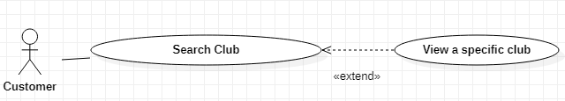

|  |  |  |  |  |
| --- | --- | --- | --- | --- |
| **USE CASE-14 SPECIFICATION z** | | | | |
| **Use-case No.** | UC014 | **Use-case Version** | | 1.0.1 |
| **Use-case Name** | Search clubs | | | |
| **Author** | Trần Dương Phúc An  Nguyễn Vũ Long  Nguyễn Đình Long  Nguyễn Văn Hiếu | | | |
| **Date** | 01/03/2021 | **Priority** | High | |
| **Actor:**  Customer  **Summary:**  *As a customer, I want to search other clubs*  **Goal:**  *Searching clubs*  **Triggers**  *Customer wants to search clubs*  **Preconditions:**  *User’s device needs to be connected in the internet*  *User successfully logged in this app with customer account*  **Post Conditions:**  *Searched clubs will be displayed on the screen*  **Main Success Scenario:**     |  |  | | --- | --- | | **Customer** | **System** | | *User click icon profile on the bottom-right corner of the screen* | System will show user’s profile | | *In the profile screen, user clicks on the magnifying glass icon to search club* | System will show *searching* text field on top screen | | *User types name’s club in searching filed and clicks magnifying glass icon to search* | *System will show a list of clubs corresponding to the search value* |   **Alternative Scenario:**  *NA*  **Exceptions:**  *NA*  **Relationships:**  Login  **Business Rules:**  *NA* | | | | |

## <View club on detail>



|  |  |  |  |  |
| --- | --- | --- | --- | --- |
| **USE CASE-15 SPECIFICATION z** | | | | |
| **Use-case No.** | UC015 | **Use-case Version** | | 1.0.1 |
| **Use-case Name** | View a club on detail | | | |
| **Author** | Trần Dương Phúc An  Nguyễn Vũ Long  Nguyễn Đình Long  Nguyễn Văn Hiếu | | | |
| **Date** | 01/03/2021 | **Priority** | High | |
| **Actor:**  **Customer**  **Summary:**  *As a customer, I want to view a club on detail so that I can know better about that club*  **Goal:**  *Viewing a club on detail*  **Triggers**  *Customer wants to view a club on detail*  **Preconditions:**  *- User’s device needs to be connected in the internet*  *- User successfully logged in this app with customer account*  *- There are clubs that customer search for that.*  **Post Conditions:**  *The specific information of a club will be displayed*  **Main Success Scenario:**   |  |  | | --- | --- | | **Customer** | **System** | | *User click icon profile on the bottom-right corner of the screen* | System will show user’s profile | | *In the profile screen, user clicks on the magnifying glass icon to search club* | System will show *searching* text field on top screen | | *User types name’s club in searching filed and clicks magnifying glass icon to search* | *System will show a list of clubs corresponding to the search value* | | *User chooses one to view it on detail* | *The club's details will appear on the screen:*  *• Name:*  *• Logo Image:*  *• Description:*  *• Average age of member:*  *• Home Pitch:*  *• Skills:* |   **Alternative Scenario:**  *NA*  **Exceptions:**  *NA*  **Relationships:**  Login  *Search Club*  **Business Rules:**  *NA* | | | | |

## <Join a club>

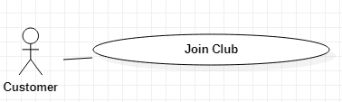

|  |  |  |  |  |
| --- | --- | --- | --- | --- |
| **USE CASE-16 SPECIFICATION z** | | | | |
| **Use-case No.** | UC016 | **Use-case Version** | | 1.0.1 |
| **Use-case Name** | Join a club | | | |
| **Author** | Trần Dương Phúc An  Nguyễn Vũ Long  Nguyễn Đình Long  Nguyễn Văn Hiếu | | | |
| **Date** | 01/03/2021 | **Priority** | High | |
| **Actor:**  **Customer**  **Summary:**  *As a customer, I want to join the particular club so that I could play football with that club*  **Goal:**  *Becoming a member to this club*  **Triggers**  Customer wants to join a club  **Preconditions:**  *- User’s device needs to be connected in the internet*  *- User successfully logged in this app with customer account*  *- That club is existed*  *- Customer is not a member of that club*  **Post Conditions:**   * *Customer request the participation of that club*   **Main Success Scenario:**  *- User successfully logged in this app with customer account*  *- Customer clicks profile icon on the top right corner*  *- Customer chooses click the magnifying glass icon to search club*  *- Customer chooses one to view detail club*  *- In the detail club, customer clicks Join button to request the participation*   |  |  | | --- | --- | | *Customer* | *System* | | *Customer clicks profile icon on the bottom right corner* | *System will redirect to “Profile” screen*  *In this screen, there is search icon to search club* | | *Customer clicks the search icon to search club and enters the name of the club* | *System will show search bar*  *System will show list of clubs depending on the result* | | *Customer chooses a specific club* | *System will show this specific club on detail*  *There is a join button to join club* | | *Customer clicks on join button* | *System will send a request to a captain of the club* |   **Alternative Scenario:**  *NA*  **Exceptions:**  *NA*  **Relationships:**  Login  *View a pitch on detail*  **Business Rules:**  *NA* | | | | |

## <Consider request participation club >

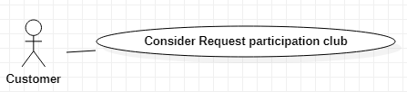

|  |  |  |  |  |
| --- | --- | --- | --- | --- |
| **USE CASE-17 SPECIFICATION** | | | | |
| **Use-case No.** | UC017 | **Use-case Version** | | 1.0.1 |
| **Use-case Name** | Consider request participation club | | | |
| **Author** | Trần Dương Phúc An  Nguyễn Vũ Long  Nguyễn Đình Long  Nguyễn Văn Hiếu | | | |
| **Date** | 01/03/2021 | **Priority** | High | |
| **Actor:**  **Customer**  **Summary:**  As a captain of a club, I want to view the request participation club so that I can admit a member  **Goal:**  Accepting for adding a member  **Triggers**  Customer wants to approve more member  **Preconditions:**  - User’s device needs to be connected in the internet  - User successfully logged in this app with customer account  - That customer must be captain  **Post Conditions:**   * A customer become a member of that club   **Main Success Scenario:**     |  |  | | --- | --- | | Club owner | System | | 1. The club owner click “Bell” icon at the bottom bar. | 1. Switch to the form contains the list of notification. | | 2. The club owner clicks on the notification that request to join the club | 2. Show details of the notice. | | 3. The club owner click “Accept” button. | 3. The system will add the applicant's information to the club. | |  |  |   **Alternative Scenario:**  NA  **Exceptions:**  NA  **Relationships:**  Login  **Business Rules:**  NA | | | | |

## <Take attendance>

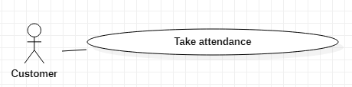

|  |  |  |  |  |
| --- | --- | --- | --- | --- |
| **USE CASE-18 SPECIFICATION** | | | | |
| **Use-case No.** | UC018 | **Use-case Version** | | 1.0.1 |
| **Use-case Name** | Take attendance | | | |
| **Author** | Trần Dương Phúc An  Nguyễn Vũ Long  Nguyễn Đình Long  Nguyễn Văn Hiếu | | | |
| **Date** | 01/03/2021 | **Priority** | High | |
| **Actor:**  **Customer**  **Summary:**  As a member of a club, I want to take attendance on the football match so that everyone on that club can see it  **Goal:**  Notifying member’s status about the football match  **Triggers**  Members in club want to take attendance  **Preconditions:**  - User successfully logged in this app with customer account  - That club has a football match  - Customer is a member of that club  **Post Conditions:**   * Club has a member’s state about that football match   **Main Success Scenario:**     |  |  | | --- | --- | | Club’s member | System | | 1. Club member click “Bell” icon at the bottom bar. | 1. Switch to the form contains the list of notification. | | 2. Club member click on the notification of the upcoming match. | 2. Show details of the notice. | | 3. Choose one state of three (I can join this match, I can’t join this match, I’m not sure) |  | | 4. Click submit to send your state to your club | 4. The system will update the member's attendance record |   **Alternative Scenario:**  NA  **Exceptions:**  Member doesn’t check status before submitting . A notification will be showed “Please choose one status”  **Relationships:**  Login  **Business Rules:**  NA | | | | |

## <Create a pitch >

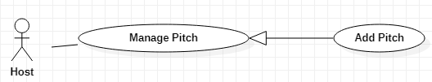

|  |  |  |  |  |
| --- | --- | --- | --- | --- |
| **USE CASE-19 SPECIFICATION** | | | | |
| **Use-case No.** | UC019 | **Use-case Version** | | 1.0.1 |
| **Use-case Name** | Create A Pitch | | | |
| **Author** | Trần Dương Phúc An  Nguyễn Vũ Long  Nguyễn Đình Long  Nguyễn Văn Hiếu | | | |
| **Date** | 2/03/2021 | **Priority** | High | |
| **Actor:**  Host  **Summary:**  As a host, I want to create a pitch for my own so that my customer can contact me  **Goal:**  Creating a pitch  **Triggers**  Host wants to create a pitch  **Preconditions:**  User successfully logged in this app with host account    **Post Conditions:**  System will send the request of creating a pitch to Admin  **Main Success Scenario:**   |  |  | | --- | --- | | Host | System | | 1. Host click “Profile” icon at the bottom bar. | 1. Switch to the form contains the host’s information detail. | | 2. Club member click on the ”+” button. | 2. Pop up the form contains list of information that need to enter.  -Name pitch: string; (not empty)  -Address: string; (not empty)  -Num of baby pitch: int;  -Phone: string;  -Time start: time;  -Time end: time;  -Price: int;  -button to add img; | | 3. Enter the information of a pitch. |  | | 4. Click “Create” button in the pop up form. | 4. The system will send add pitch request to admin. Then show Successful notify. |   **Alternative Scenario:**  NA  **Exceptions:**  The system will display an announcement if host doesn’t fill in some important information before clicking “Create” button  **Relationships:**  Login  View my pitches  **Business Rules:**  Host creates a pitch which has to be existed in real life | | | | |

## <Update pitch>

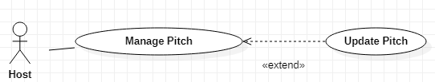

|  |  |  |  |  |
| --- | --- | --- | --- | --- |
| **USE CASE-20 SPECIFICATION** | | | | |
| **Use-case No.** | UC020 | **Use-case Version** | | 1.0.1 |
| **Use-case Name** | Update A Pitch | | | |
| **Author** | Trần Dương Phúc An  Nguyễn Vũ Long  Nguyễn Đình Long  Nguyễn Văn Hiếu | | | |
| **Date** | 2/03/2021 | **Priority** | High | |
| **Actor:**  Host  **Summary:**  As a host, I want to update my pitch so that my pitch’s information could be fixed properly  **Goal:**  Updating a pitch  **Triggers**  Host wants to create a pitch  **Preconditions:**  User’s device needs to be connected in the internet  User successfully logged in this app with host account    **Post Conditions:**  System will send the request of updating a pitch to Admin  **Main Success Scenario:**  Host needs to log in successfully  Host goes to “My pitches” field  Host clicks “Update” button in specific pitch  Host changes some pitch’s information  Host clicks in “Submit” button   |  |  | | --- | --- | | Host | System | | 1. Host click “Profile” icon at the bottom bar. | 1. Switch to the form contains the list of notification. | | 2. The host presses to specific pitch that they want to change. | 2. Show details of the pitch. | | 3. The host presses “Update” button. | 3. Pop up the form contains list of information that can modify.  -Name pitch: string; (not empty)  -Address: string; (not empty)  -Num of baby pitch: int;  -Phone: string;  -Time start: time;  -Time end: time;  -Price: int;  -button to add img; | | 4. Click “Save” button in the pop up form. | 4. The system will update the pitch record. Then back to Profile screen. |   **Alternative Scenario:**  NA  **Exceptions:**  The system will display an announcement if host doesn’t obey data types of pitch’s information before clicking on “Submit’ button  **Relationships:**  Login  View my pitches  **Business Rules:**  The updated information must be real | | | | |

## <Delete a pitch>

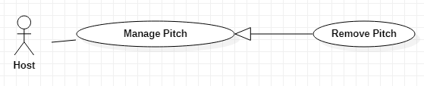

|  |  |  |  |  |
| --- | --- | --- | --- | --- |
| **USE CASE-21 SPECIFICATION** | | | | |
| **Use-case No.** | UC021 | **Use-case Version** | | 1.0.1 |
| **Use-case Name** | Delete A Pitch | | | |
| **Author** | Trần Dương Phúc An  Nguyễn Vũ Long  Nguyễn Đình Long  Nguyễn Văn Hiếu | | | |
| **Date** | 2/03/2021 | **Priority** | High | |
| **Actor:**  Host  **Summary:**  As a host, I want to delete my pitch so that my pitch will be deleted if it is closed  **Goal:**  Deleting a pitch  **Triggers**  Host wants to delete a pitch  **Preconditions:**  User successfully logged in this app with host account    **Post Conditions:**  Pitch will be deleted from DB  **Main Success Scenario:**  Host click “Profile” icon at the bottom bar    The system will pop up a confirmation for host to confirm  Host clicks in “Yes” button in the confirmation   |  |  | | --- | --- | | Host | System | | 1. Host click “Profile” icon at the bottom bar. | 1. Switch to the form contains the list of notification. | | 2. Host clicks “trash can” icon in the next of pitch which they want to delete | 2. Show confirm message. | | 3. The host presses “Yes” button. | 3. System will send request deletion to Admin. |   **Alternative Scenario:**  NA  **Exceptions:**  System will display an announcement if the pitch doesn’t exist in the system  **Relationships:**  Login  View my pitches  **Business Rules:**  NA | | | | |

## <View my pitches>

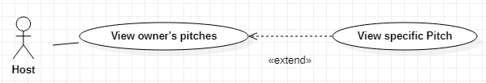

|  |  |  |  |  |
| --- | --- | --- | --- | --- |
| **USE CASE-22 SPECIFICATION** | | | | |
| **Use-case No.** | UC022 | **Use-case Version** | | 1.0.1 |
| **Use-case Name** | View my pitches | | | |
| **Author** | Trần Dương Phúc An  Nguyễn Vũ Long  Nguyễn Đình Long  Nguyễn Văn Hiếu | | | |
| **Date** | 2/03/2021 | **Priority** | High | |
| **Actor:**  Host  **Summary:**  As a host, I want to view my pitches so that I can manage my pitches  **Goal:**  Viewing my pitches  **Triggers**  Host wants to View host’s pitches  **Preconditions:**  User successfully logged in this app with host account  **Post Conditions:**  My pitches will be displayed  **Main Success Scenario:**     |  |  | | --- | --- | | Host | System | | 1. Host click “Profile” icon at the bottom bar. | 1. Switch to the form contains profile and list of pitch. | |  |  |   **Alternative Scenario:**  if host does not currently own a pitch.   |  |  | | --- | --- | | Host | System | | 1. Host click “Profile” icon at the bottom bar. | 1. Switch to the form contains profile and show lable “You don’t have any pitch now”. | |  |  |   **Exceptions:**  NA  **Relationships:**  Login  **Business Rules:**  NA | | | | |

## <View booked pitch history>

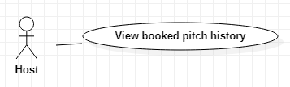

|  |  |  |  |  |
| --- | --- | --- | --- | --- |
| **USE CASE-23 SPECIFICATION** | | | | |
| **Use-case No.** | UC023 | **Use-case Version** | | 1.0.1 |
| **Use-case Name** | View booked pitches history | | | |
| **Author** | Trần Dương Phúc An  Nguyễn Vũ Long  Nguyễn Đình Long  Nguyễn Văn Hiếu | | | |
| **Date** | 2/03/2021 | **Priority** | High | |
| **Actor:**  *Host*  **Summary:**  *As a host, I want to view my booked pitches history so that I will know how my pitches go*  **Goal:**  *View booked pitches history*  **Triggers**  Host wants to view booked pitches history  **Preconditions:**  *User’s device needs to be connected in the internet*  *User successfully logged in this app with host account*  **Post Conditions:**  *All of my booked pitches will be displayed*  **Main Success Scenario:**  *Host needs to log in successfully*  *Host needs to click on “Booked Pitches History” field*  *All of host’s booked pitches will be displayed*   |  |  | | --- | --- | | *Host* | *System* | | *Clicking on “Booked pitch history” tab* | *System will redirect to “Booked pitches history” screen*  *System will show the list of booked pitch history on the screen*  *A booked pitch will show:*   * *User Name* * *Pitch’s name* | | *Host clicks on a specific booked pitch* | *System will receive host’s request and display that specific booked pitch on detail*  *It will show:*   * *Pitch’s Name* * *User Name* * *Time Start* * *Time End* * *Date* * *Total price* |   **Alternative Scenario:**  *NA*  **Exceptions:**  *System will display a message if there are no existing booked pitches*  **Relationships:**  Login  **Business Rules:**  *NA* | | | | |

## <View upcoming matches>

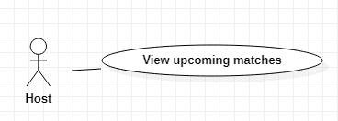

|  |  |  |  |  |
| --- | --- | --- | --- | --- |
| **USE CASE-24 SPECIFICATION z** | | | | |
| **Use-case No.** | UC024 | **Use-case Version** | | 1.0.1 |
| **Use-case Name** | View upcoming matches | | | |
| **Author** | Trần Dương Phúc An  Nguyễn Vũ Long  Nguyễn Đình Long  Nguyễn Văn Hiếu | | | |
| **Date** | 2/03/2021 | **Priority** | High | |
| **Actor:**  *Host*  **Summary:**  *As a host, I want to view upcoming pi so that I will know that how many matches will be happened in my pitch*  **Goal:**  *Viewing upcoming matches*  **Triggers**  Host wants to view upcoming matches  **Preconditions:**  *User’s device needs to be connected in the internet*  *User successfully logged in this app with host account*  **Post Conditions:**  *All of upcoming matches at my pitches will be displayed*  **Main Success Scenario:**     |  |  | | --- | --- | | *Host* | *System* | | *Clicking on “Upcoming matches” tab* | *System will redirect to the “Upcoming matches” screen*  *All upcoming matches of host’s pitch will be displayed on the screen*  *An Upcoming match will show:*   * *Pitch’s Name* * *Time Start* * *Time End* * *Date* |   **Alternative Scenario:**  *NA*  **Exceptions:**  *System will display an announcement if there are no existing upcoming matches*  **Relationships:**  Login  **Business Rules:**  *NA* | | | | |

## <Approve registration of host>

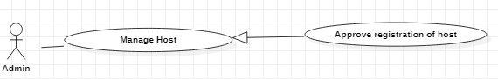

|  |  |  |  |  |
| --- | --- | --- | --- | --- |
| **USE CASE-25 SPECIFICATION z** | | | | |
| **Use-case No.** | UC025 | **Use-case Version** | | 1.0.1 |
| **Use-case Name** | Approve registration of host | | | |
| **Author** | Trần Dương Phúc An  Nguyễn Văn Hiếu  Nguyễn Đình Long  Nguyễn Vũ Long | | | |
| **Date** | 19/01/2021 | **Priority** | High | |
| **Actor:**  *Admin*  **Summary:**  *As an admin, I want to approve registration of host*  **Goal:**  *Managing the host's initialization*  **Triggers**  *When guest wants to register as a host*  **Preconditions:**  *User successfully logged in this app with admin account*  *There is host’s registration of user*  **Post Conditions:**  *The user successfully registers an account with the right to be the host*  *The success message is sent to host*  **Main Success Scenario:**  *Admin receives the user's host registration form*  *Admin examines the necessary information and press the Apply button*   |  |  | | --- | --- | | *Admin* | *System* | | *Clicking on a bell symbol (notification)* | *If there is a user who registers the account as a host ,System will create a new registraion form and send it to admin’s notification* | | *Admin examines necessary information and clicks on Apply button* | *System will receive the cofirmation of the admin and set the confirmed account’s role to host*  *The notification of registration form will be faded* |     **Alternative Scenario:**  *N/A*  **Exceptions:**  *Admin doesn’t receive the user's host registration form*  **Relationships:**  *Register*  **Business Rules:**  *NA* | | | | |

## <Ban an account>

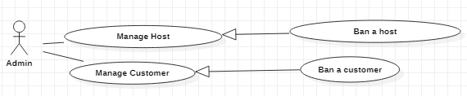

|  |  |  |  |  |
| --- | --- | --- | --- | --- |
| **USE CASE-26 SPECIFICATION z** | | | | |
| **Use-case No.** | UC026 | **Use-case Version** | | 1.0.1 |
| **Use-case Name** | Ban an Account | | | |
| **Author** | Trần Dương Phúc An  Nguyễn Văn Hiếu  Nguyễn Đình Long  Nguyễn Vũ Long | | | |
| **Date** | 19/01/2021 | **Priority** | High | |
| **Actor:**  *Admin*  **Summary:**  *As an admin, I want to ban an account so that I can do something regarding to my role*  **Goal:**  *Banning an account*  **Triggers**  *This use case works when admin wants to ban an available account*  **Preconditions:**  *User successfully logged in this app with admin account*  *Customer reports a host*  *Host reports a customer*  **Post Conditions:**  *User successfully logged in this app with admin account*  *Account couldn’t be logged in because of being banned by admin*  *A notification message is sent to reporter*  *Every single inforamtion of banned account will be disappeared*    **Main Success Scenario:**  *Admin clicks View Report button*  *Admin selects a specific report that they want to review*  *Admin detects those things that user violates the standards and rules of this application*  *Admin clicks on Ban button*     |  |  | | --- | --- | | *Admin* | *System* | | *Clicking on “Report” tab* | *System will redirect to “Report” screen*  *If there are hosts who report customers, System will create new reports form and add them to list of reports*  *List of reports will be displayed on the screen* | | *Admin selects a specific report to review* | *System will receive the admin’s request and pop up that specific report on detail* | | *Admin detects those things that user violates the standards and rules of this application or not*  *Admin clicks on Ban button* | *System will set the banned account’s status to inactive in database*  *That specific report will be faded off* |   **Alternative Scenario:**  *N/A*  **Exceptions:**  *System will throw a notification if the account was banned*  **Relationships:**  Login  View Report  **Business Rules:**  *NA* | | | | |

## <Approve creation of a pitch>

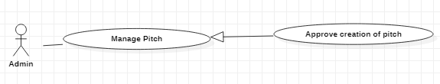

|  |  |  |  |  |
| --- | --- | --- | --- | --- |
| **USE CASE-27 SPECIFICATION z** | | | | |
| **Use-case No.** | UC027 | **Use-case Version** | | 1.0.1 |
| **Use-case Name** | Approve Creation A Pitch | | | |
| **Author** | Trần Dương Phúc An  Nguyễn Văn Hiếu  Nguyễn Đình Long  Nguyễn Vũ Long | | | |
| **Date** | 19/01/2021 | **Priority** | Normal | |
| **Actor:**  *Admin*  **Summary:**  *As an admin, I want to approve creation of pitch*  **Goal:**  *Approving creation of pitch*  **Triggers**  *Admin wants to approve creation of pitch*  *Clicking on Apply button on creation form of host*  **Preconditions:**  *User successfully logged in this app with admin account*  *There is host’s update pitch of user*  **Post Conditions:**  *User successfully logged in this app with admin account*  *Host creates pitch successfully*  *Successful message is sent to host who creates pitch*  **Main Success Scenario:**  *Host inputs necessary information to create a pitch*  *Host clicks Create button*  *Creation Pitch Form is sent to admin*  *Admin reviews and clicks on Apply button*   |  |  | | --- | --- | | *Admin* | *System* | | *Clicking on the bell (notification)* | *If there is a host who creates a new pitch, System will create a new creation of a pitch form and send it to admin’s notification* | | *Admin examines the necessary information of creation pitch form and clicks on Apply button* | *System will receive the admin’s request and create a new pitch*  *System will add the pitch to list of all pitches* |   **Alternative Scenario:**  *N/A*  **Exceptions:**  *NA*  **Relationships:**  *Create A Pitch*  **Business Rules:**  *NA* | | | | |

## <View Reports>

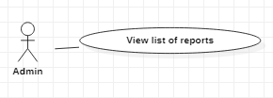

|  |  |  |  |  |
| --- | --- | --- | --- | --- |
| **USE CASE-28 SPECIFICATION** | | | | |
| **Use-case No.** | UC028 | **Use-case Version** | | 1.0.1 |
| **Use-case Name** | View reports | | | |
| **Author** | Trần Dương Phúc An  Nguyễn Văn Hiếu  Nguyễn Đình Long  Nguyễn Vũ Long | | | |
| **Date** | 19/01/2021 | **Priority** | Hard | |
| **Actor:**  *Admin*  **Summary:**  *As admin, I want to view list reports*  **Goal:**  *Showing list of reports*  **Triggers**  *Admin wants to view list reports*  **Preconditions:**  *User successfully logged in this app with admin account*  **Post Conditions:**  *The viewed report will be grayed out on the list report*  **Main Success Scenario:**  *Admin accesses the application*  *Admin successfully logged in this app with admin account*  *Admin clicks on View Report button*  *A list of reports is showed on screen order by descending time*  *Admin clicks on a specific report that they want to view*  *Detailed report will be showed on the screen*   |  |  | | --- | --- | | *Admin* | *System* | | *Clicking on “Report” tab* | *System will redirect to “Report” screen*  *All of reports will be shown on the screen (ban request)* | | *Admin clicks on a specific report to view* | *System will receive the admin’s request and pop up that specific report on detail* |   **Alternative Scenario:**  *NA*  **Exceptions:**  *NA*  **Relationships:**  *Login*  **Business Rules:**  *NA* | | | | |

## <Approve update of a pitch>

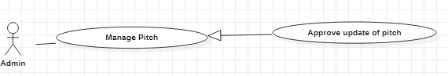

|  |  |  |  |  |
| --- | --- | --- | --- | --- |
| **USE CASE-29 SPECIFICATION** | | | | |
| **Use-case No.** | UC0029 | **Use-case Version** | | 1.0.1 |
| **Use-case Name** | Approve Update A Pitch | | | |
| **Author** | Trần Dương Phúc An  Nguyễn Văn Hiếu  Nguyễn Đình Long  Nguyễn Vũ Long | | | |
| **Date** | 19/01/2021 | **Priority** | Normal | |
| **Actor:**  *Admin*  **Summary:**  *As an admin, I want to approve update of pitch*  **Goal:**  *Approving update of pitch*  **Triggers**  *Admin wants to approve update of pitch*  *Clicking on Apply button on creation form of host*  **Preconditions:**  *User successfully logged in this app with admin account*  *There is host’s update pitch of user*  **Post Conditions:**  *Host updates pitch successfully*  *Successful message is sent to host who create pitch*  **Main Success Scenario:**  *Host inputs necessary information to update a pitch*  *Host clicks on Update button*  *Update Pitch Form is sent to admin*  *Admin reviews and clicks on Apply button*   |  |  | | --- | --- | | *Admin* | *System* | | *Clicking on the bell (notification)* | *If There is a host who updates pitch’s information, System will create a new update pitch form and send it to admin’s notification* | | *Admin examines the necessary information of update pitch and clicks on Apply button* | *System will receive the admin’s request and update pitch’s information depending the update form* |   **Alternative Scenario:**  *N/A*  **Exceptions:**  *NA*  **Relationships:**  *Update A Pitch*  **Business Rules:**  *NA* | | | | |

## <Reject a booking pitch>

|  |  |  |  |  |
| --- | --- | --- | --- | --- |
| **USE CASE-30 SPECIFICATION** | | | | |
| **Use-case No.** | UC0030 | **Use-case Version** | | 1.0.1 |
| **Use-case Name** | Reject a booking pitch | | | |
| **Author** | Trần Dương Phúc An  Nguyễn Văn Hiếu  Nguyễn Đình Long  Nguyễn Vũ Long | | | |
| **Date** | 19/01/2021 | **Priority** | Normal | |
| **Actor:**  *Host*  **Summary:**  *As a Host, I want to reject a booking pitch directly*  **Goal:**  *To reject a booking pitch*  **Triggers**  *Host wants to reject a booking pitch*  **Preconditions:**  *User successfully logged in this app with Host account*  *User’s device has to be connected to the internet*  **Post Conditions:**  *A booking pitch will be rejected from booked pitch history*  **Main Success Scenario:**     |  |  | | --- | --- | | *Host* | *System* | | *Clicking on the bell (notification)* | *If There is a user who books a pitch, System will create a new notification and send it to host’s notification* | | *Host clicks on a specific booking pitch notification to view it on detail* | *System will receive the host’s request and display that notification on detail* | | *In the detailed screen, Host clicks on Reject button* | *System will remove that booking pitch from booked pitch history* |   **Alternative Scenario:**  *N/A*  **Exceptions:**  *NA*  **Relationships:**  *Login*  *View booked pitch history*  **Business Rules:**  *NA* | | | | |

# NON-FUNCTIONAL Requirements

[This section describes the non-functional requirements of the system. Some examples are listed as below]

## Usability

The application is easy to use through a simple interface that is easily accessible to users.

Users only need about 2 hours to use the application proficiently.

## Reliability

If the application has 200 users accessing at the same time, the response of this application will be reduced performance.

If there are 2 different devices accessing the same account, 1 OTP will be sent to the last access device to authenticate the user's login.

## Performance

**1. Startup Time**

The application should display the opened document within 10s after it is started.

**2. Edit Response Time**

The application should display updated values within 1s after user triggers the edit operation.

**3. Smooth Scrolling**

While a user scrolls the requirements table, the application should not display scrolling jerks longer than 200ms.